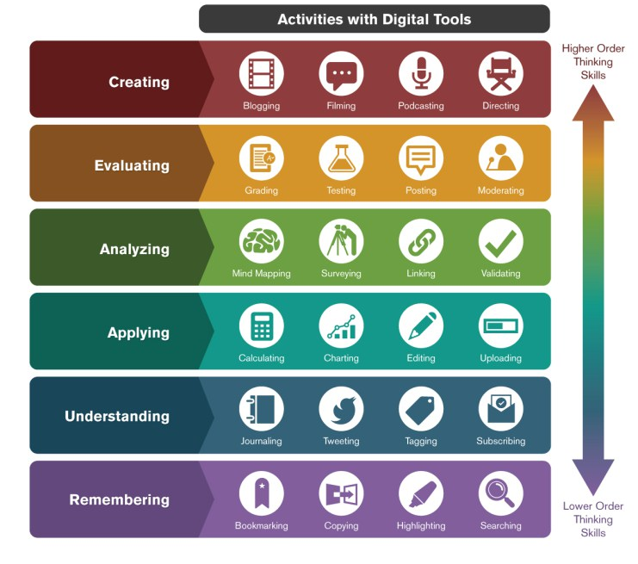
Figure 1. Bloom’s Digital Taxonomy
(Infographic Credit: Ron Carranza, as cited in Sneed, 2016)

